PH20105 Experimental Physics & Computing 2

MATLAB assignment

Candidate number: 23142

Date: 29/11/19

Q1:

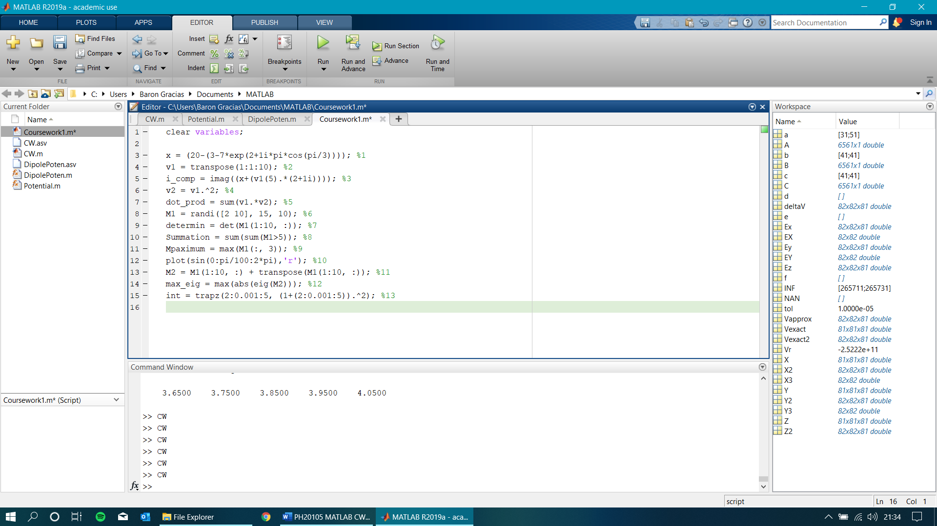

Q2:

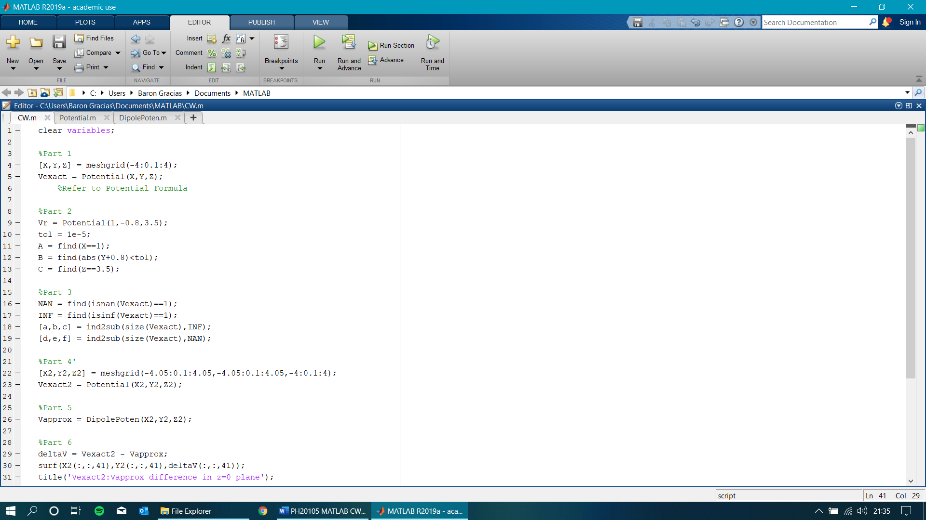

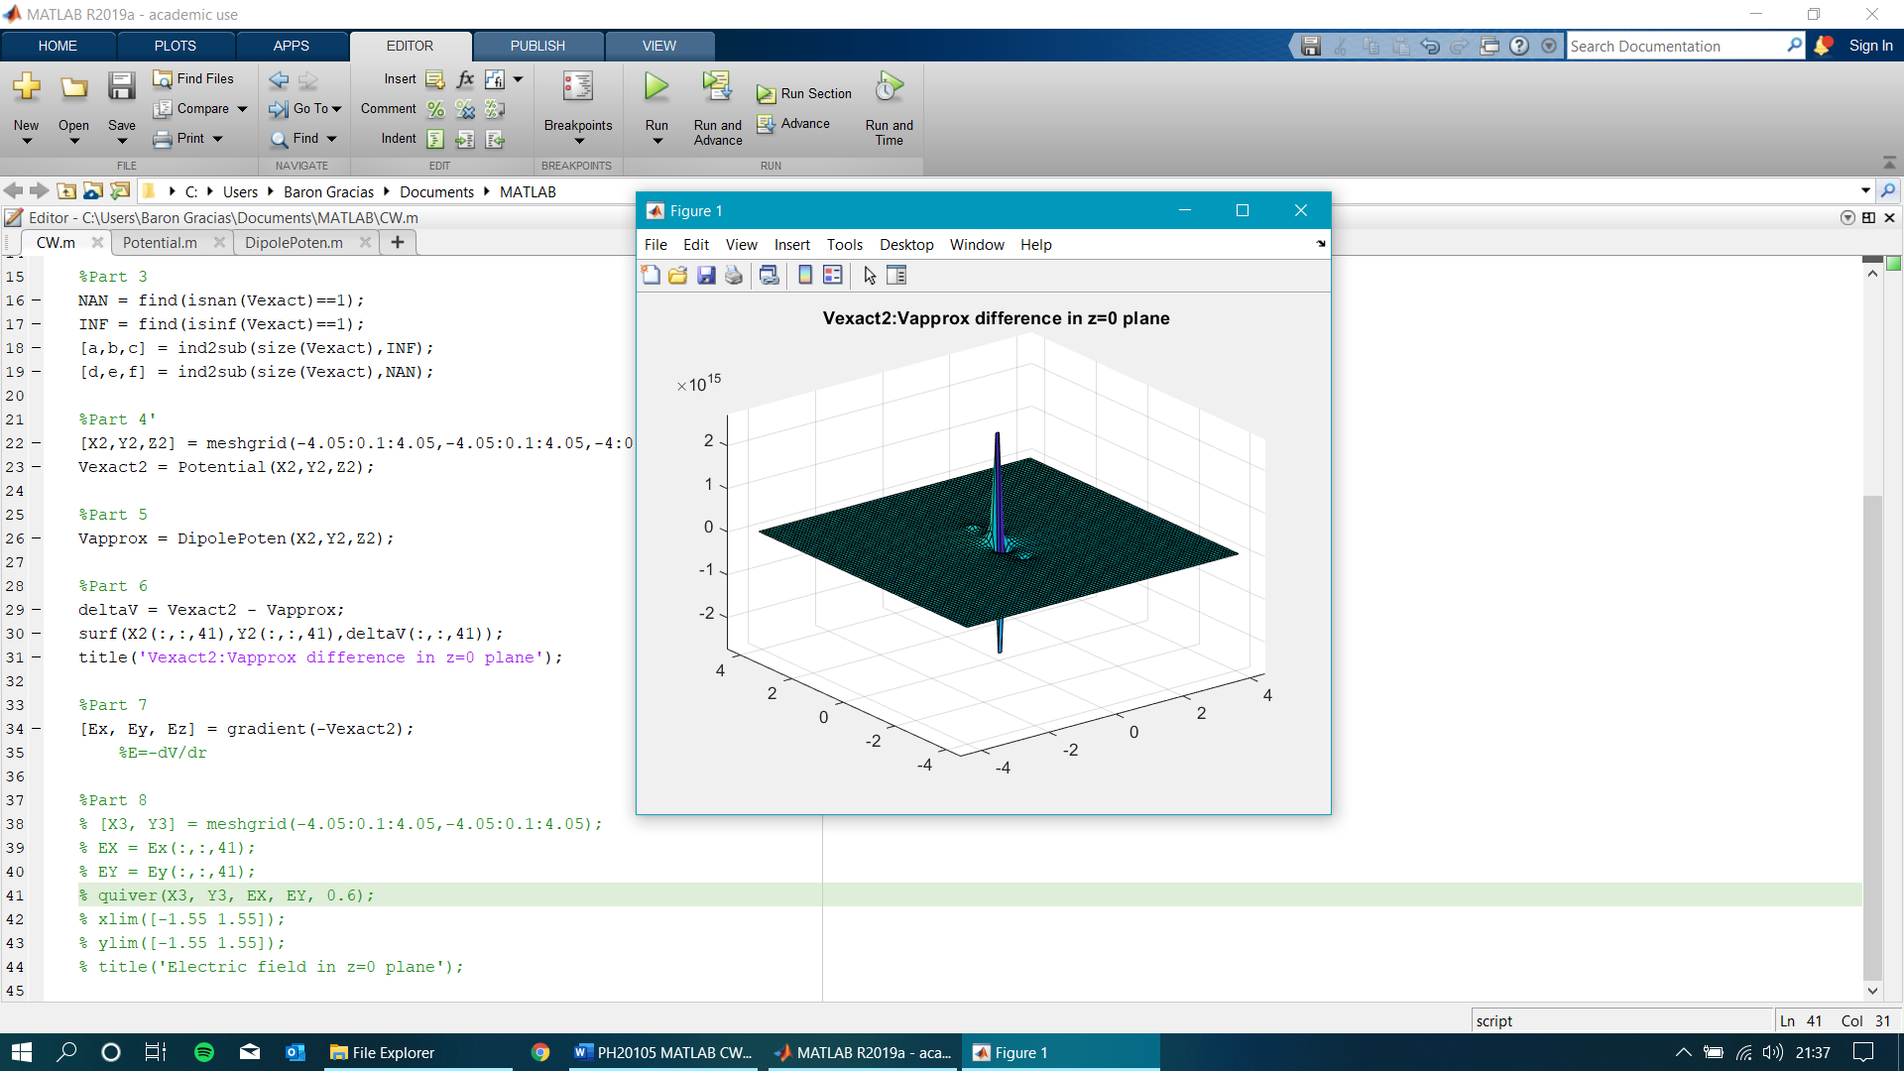

Main features:

Two clearly defined peaks, one at -ve and +ve corresponding to the charges. At large distances from the charges, the difference in potential tends to zero as shown by the flattened surface. The two smaller dimples next to the peaks are the positions of the charges, and the potential difference formula is centred at (0,0,0) in this plane, hence the potential shooting up/down.

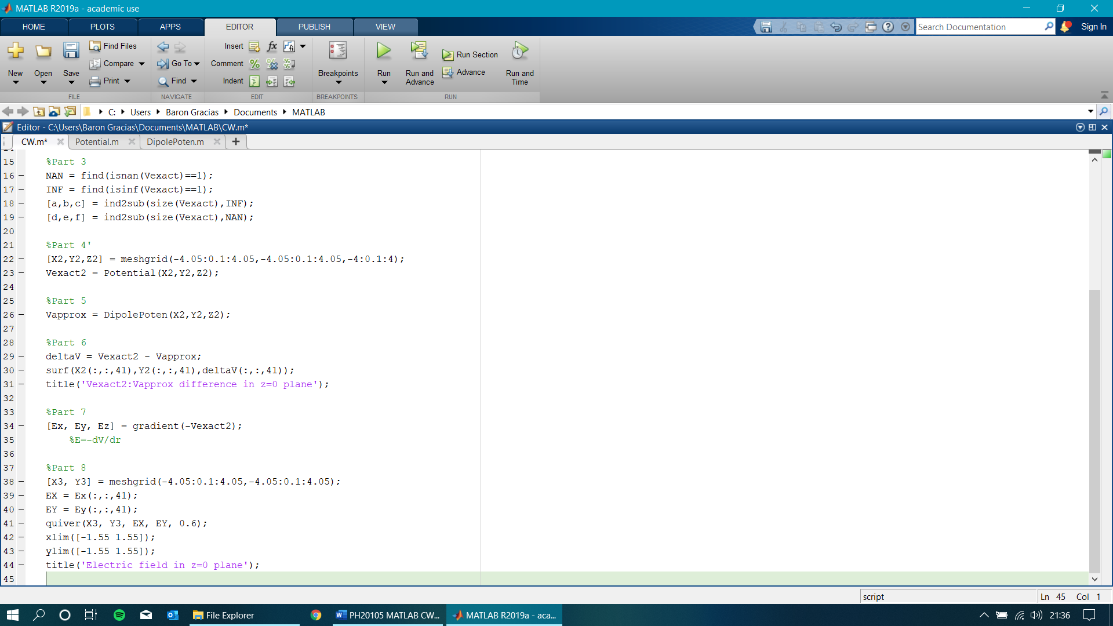

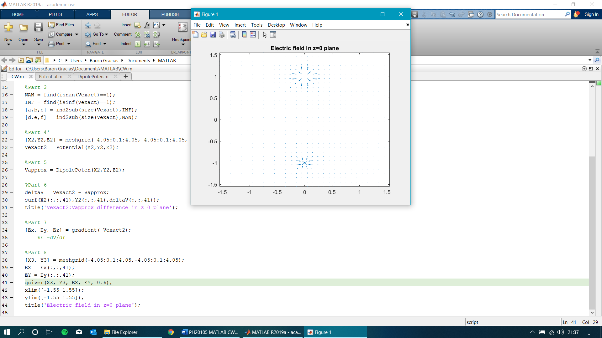

Formulas Defined:

